Task 2 - Descriptive Analysis

Distribution of Loan Amount, EMI Amount, and Credit Score.
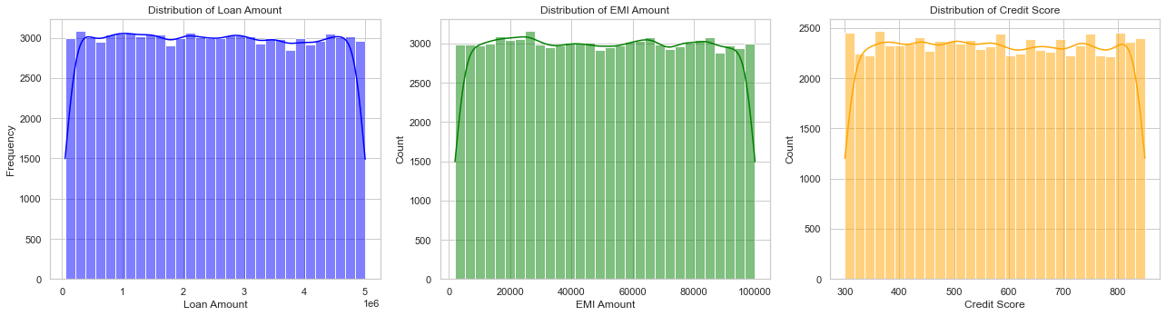
### Regional trends in loan disbursement and defaults

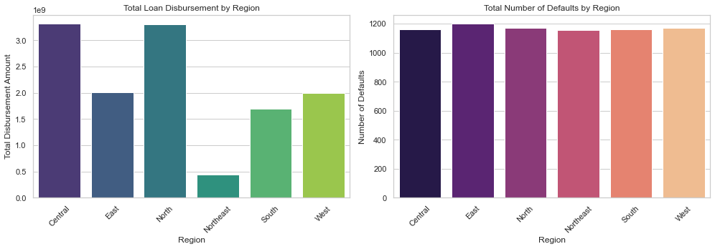

Monthly Trends in Approvals and Disbursements¶

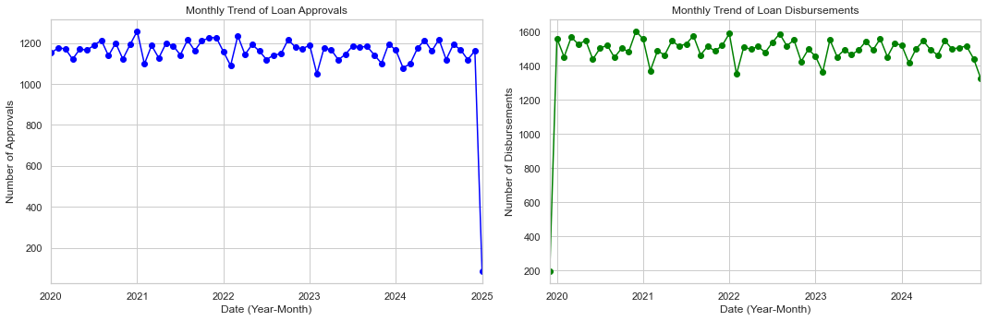

Task 3 - Default Risk Analysis
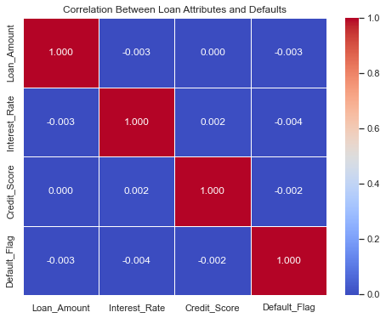

Pairwise Correlation Analysis

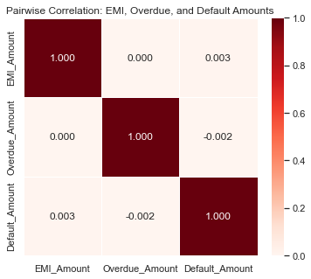

Correlation Between Branch Metrics and Defaults
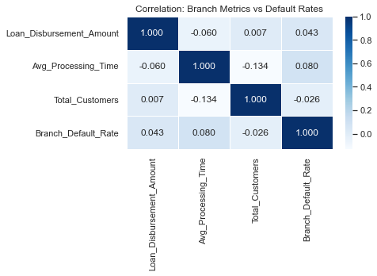

Task 4 - Branch and Regional Performance

Branches Ranking

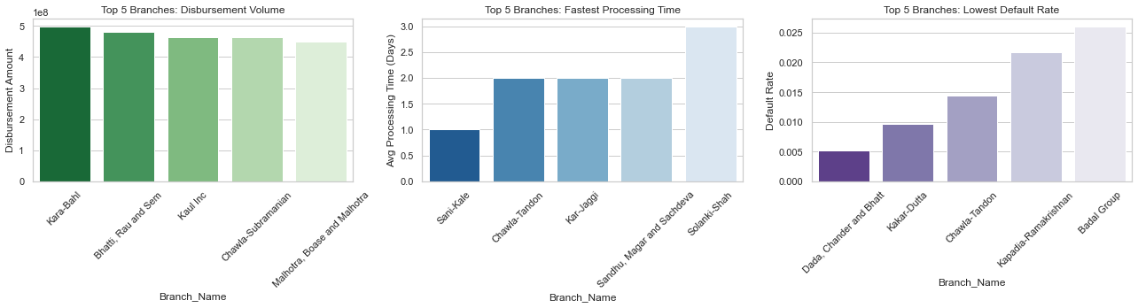
----------------------------------------
Average Recovery Rates by Region:
Region Recovery_Rate
Central 0.447717
Northeast 0.411552
South 0.409559
North 0.382243
West 0.374519
East 0.357711

Comparing branch performance across regions
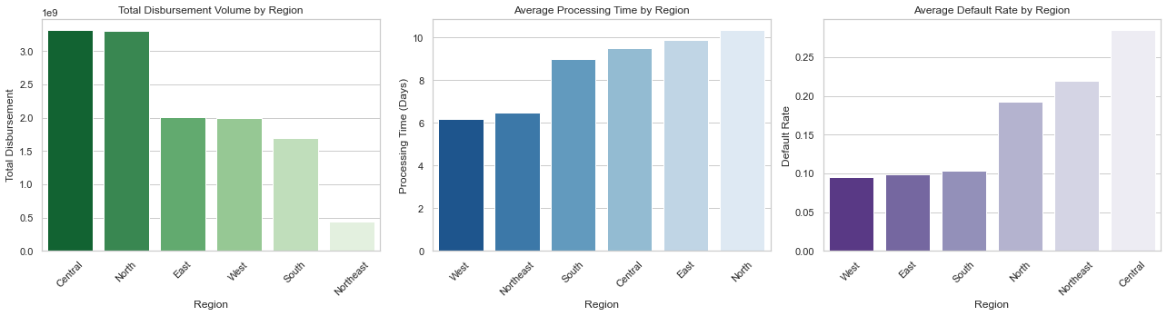

Task 5 - Customer Segmentation

Segmenting customers by their income, credit score, and loan status
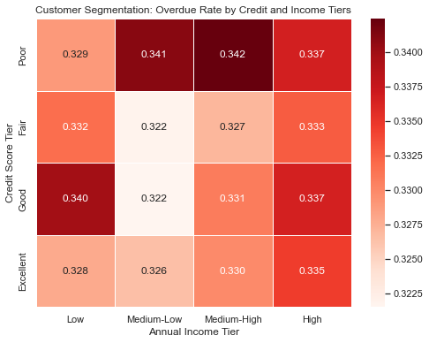

Loan Status Counts by Credit Tier:
----------------------------------------
Loan_Status Active Closed Overdue
Credit_Tier
Poor 7483 7452 7598
Fair 7529 7624 7406
Good 7487 7570 7491
Excellent 7551 7438 7371

Identifing high-risk and high-value customer groups

TOP 3 HIGH-RISK CUSTOMER GROUPS
--------------------------------------------------
Credit_Tier Income_Tier Total_Customers Average_Loan_Amount Overdue_Rate
Poor Medium-High 5631 2.511800e+06 0.342390
Poor Medium-Low 5567 2.491574e+06 0.340938
Good Low 5520 2.506209e+06 0.339855

==================================================

TOP 3 HIGH-VALUE CUSTOMER GROUPS
--------------------------------------------------
Credit_Tier Income_Tier Total_Customers Average_Loan_Amount Overdue_Rate
Good Medium-Low 5570 2.537639e+06 0.321544
Fair Medium-Low 5773 2.512022e+06 0.321843
Excellent Medium-Low 5590 2.506972e+06 0.326476

Analysing repayment behavior across segments
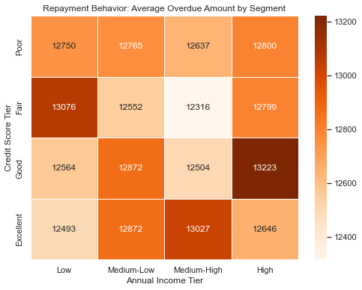
Percentage of Transactions that are Penalties (by Credit Tier):
------------------------------------------------------------
Credit_Tier
Poor 49.96%
Fair 50.06%
Good 50.05%
Excellent 50.21%
dtype: object

Task 6 - Advanced Statistical Analysis

Correlation Analysis for Default Risks¶

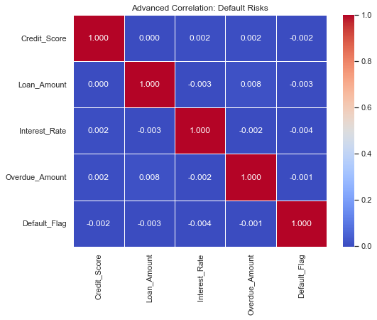

Pairwise Correlation Heatmap
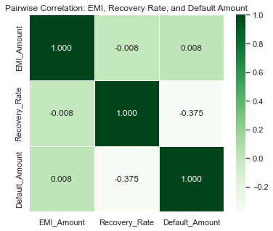

Branch-Level Correlation
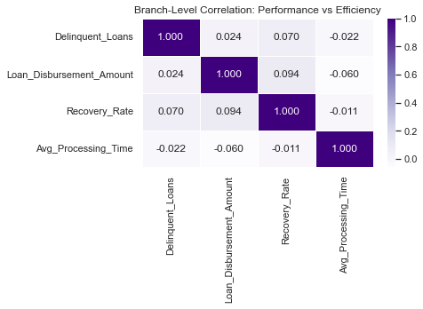

Task 7 - Transaction and Recovery Analysis

Analysing Penalty Payments and Overdue Trends
Total Number of Transactions by Type:
----------------------------------------
Penalty 247844
EMI 247156
Name: Payment_Type, dtype: int64

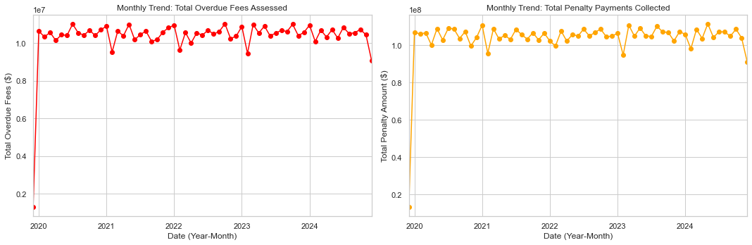

Evaluating recovery rates by Default_Reason and Legal_Action.
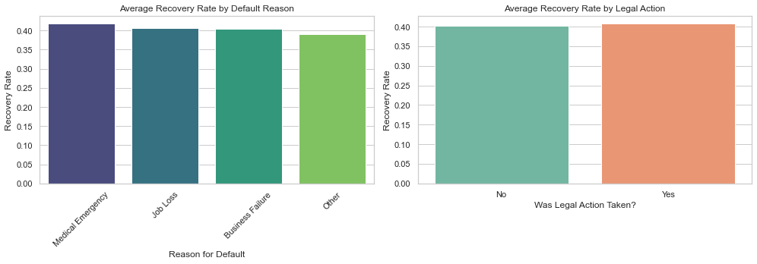
Impact of Legal Action on Recovery Rates:
--------------------------------------------------
Legal Action No: 40.18% recovered on average.
Legal Action Yes: 40.74% recovered on average.

Comparing recovery rates across regions and branches¶
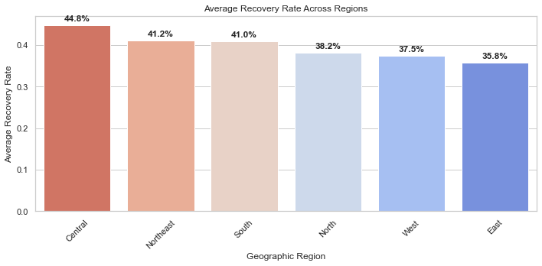

Task 8 - EMI Analysis

Analyze the relationship between EMI amounts and default probabilities.
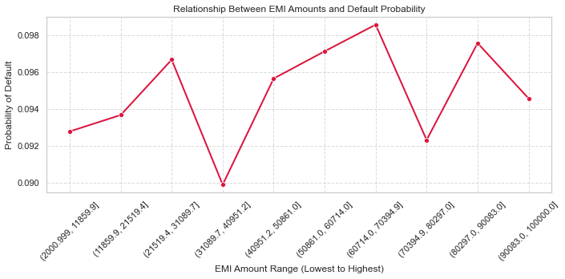

Identifing thresholds for EMI amounts where defaults are most likely
HIGH RISK EMI THRESHOLDS
Company Average Default Rate: 9.49%
------------------------------------------------------------
The following EMI ranges exceed the average default risk:
EMI_Bucket_Str Default_Flag
(21519.4, 31089.7] 0.096667
(40951.2, 50861.0] 0.095645
(50861.0, 60714.0] 0.097122
(60714.0, 70394.9] 0.098567
(80297.0, 90083.0] 0.097566

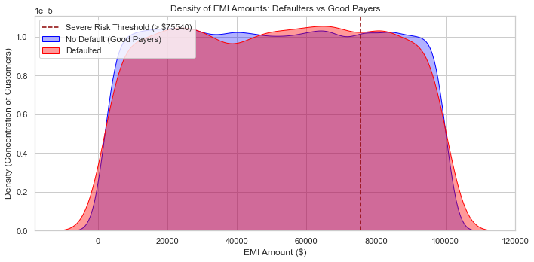

Comparing EMI trends across loan types
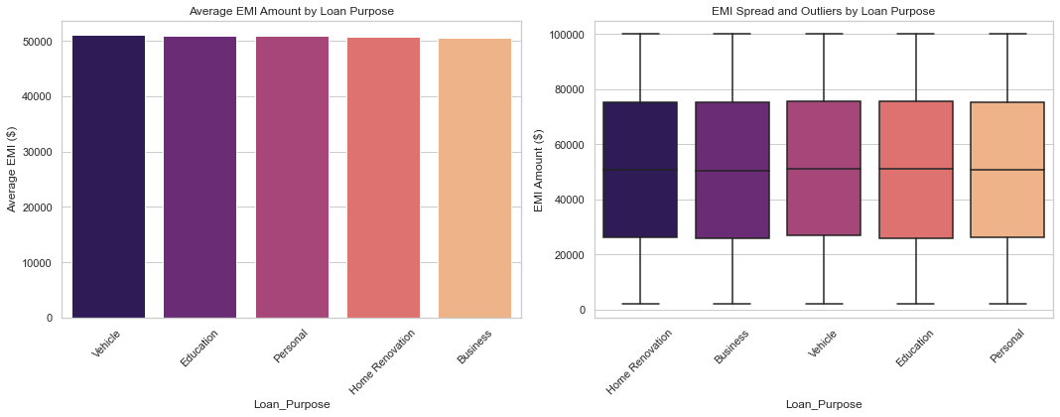
📊 Average EMI by Loan Purpose:
-----------------------------------
Loan_Purpose EMI_Amount
Vehicle 51107.317521
Education 50941.563688
Personal 50890.346147
Home Renovation 50775.452007
Business 50628.547454

Task 9 - Loan Application Insights

Calculating approval and rejection rates for loan applications.¶
📊 Loan Application Status Rates:
----------------------------------------
Approved: 84.75% (70000 total applications)
Rejected: 15.25% (12600 total applications)

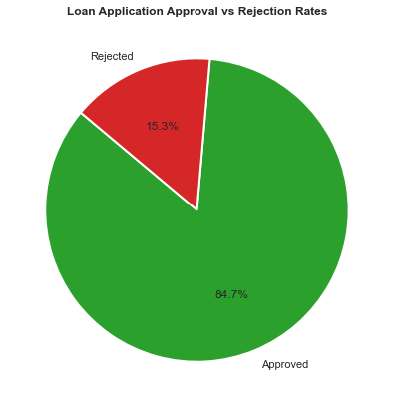

Identifing the most common reasons for loan rejection¶

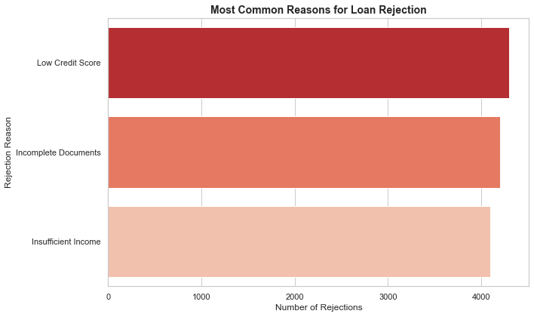
❌ Top Reasons for Loan Rejection:
---------------------------------------------
Low Credit Score: 4297 applications (34.1%)
Incomplete Documents: 4204 applications (33.4%)
Insufficient Income: 4099 applications (32.5%)

Processing Fees: Approved vs Rejected¶

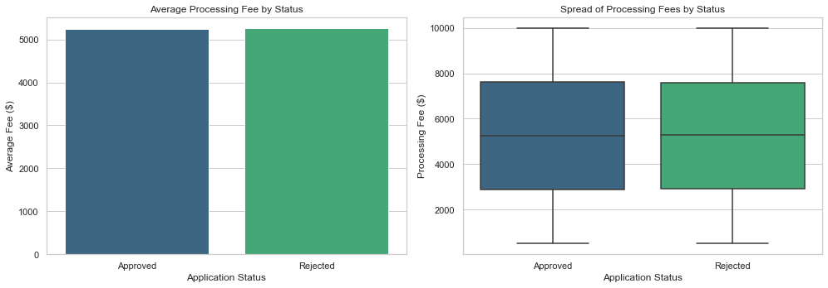
💰 Average Processing Fee by Status:
-----------------------------------
Approved: $5252.40
Rejected: $5255.14

Task 10 - Recovery Effectiveness

Overall Recovery Ratio
📈 OVERALL RECOVERY EFFECTIVENESS 📈
---------------------------------------------
Total Default Amount: $476,807,757.00
Total Recovered Amount: $115,919,813.00
Overall Recovery Ratio: 24.31%
---------------------------------------------

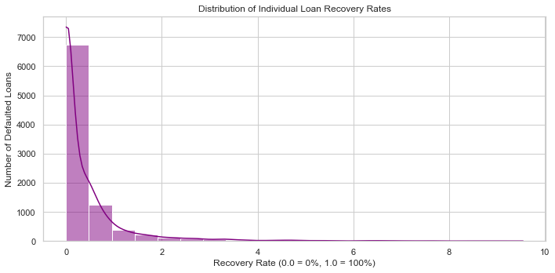

Recovery Rates: With vs. Without Legal Action

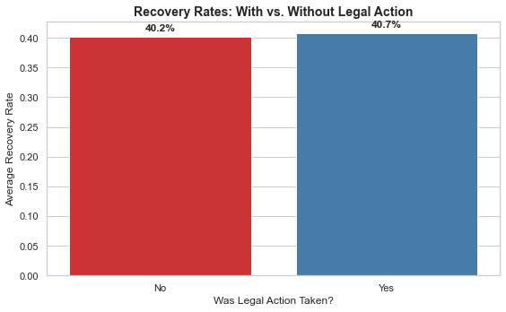
⚖️ Recovery Rates by Legal Action:
-----------------------------------
Legal Action 'No': 40.18% average recovery
Legal Action 'Yes': 40.74% average recovery

Analyzing branch-wise recovery performance.
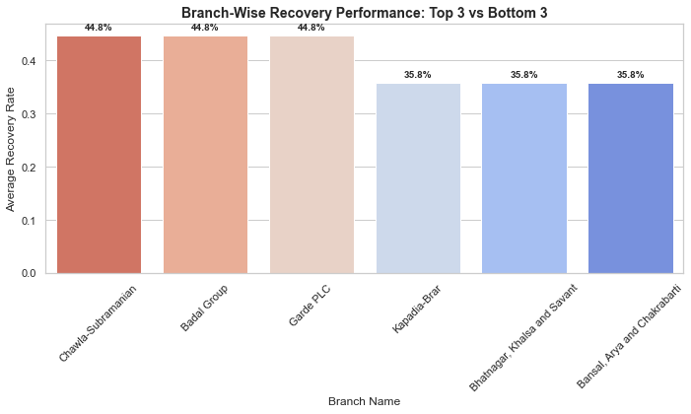
🏆 TOP 3 PERFORMING BRANCHES (Collections):
---------------------------------------------
Branch_Name Recovery_Rate
Chawla-Subramanian 0.447717
Badal Group 0.447717
Garde PLC 0.447717

🚨 BOTTOM 3 PERFORMING BRANCHES (Collections):
---------------------------------------------
Branch_Name Recovery_Rate
Kapadia-Brar 0.357711
Bhatnagar, Khalsa and Savant 0.357711
Bansal, Arya and Chakrabarti 0.357711

Task 11 - Loan Disbursement Eﬃciency

Analyzing the time from application to loan disbursement and identify bottlenecks

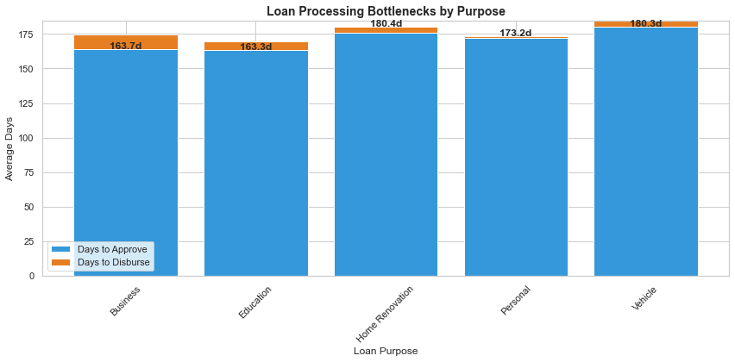
🕒 Efficiency Metrics by Loan Category:
--------------------------------------------------
Loan_Purpose App_to_Approval Approval_to_Disbursal
Business 174.435870 -10.710611
Education 169.675376 -6.327774
Home Renovation 175.803845 4.548235
Personal 172.167480 1.025534
Vehicle 184.805873 -4.536776

Comparing average processing times across branches

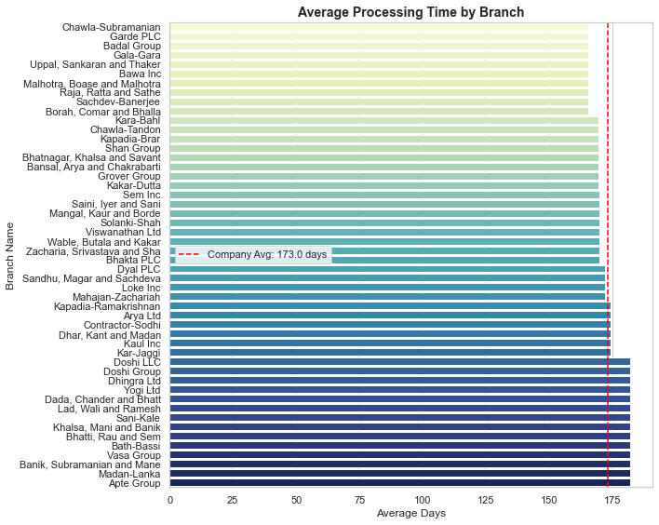
🚀 Fastest Branch: Chawla-Subramanian (165.5 days)
🐢 Slowest Branch: Apte Group (181.8 days)

Evaluating disbursement trends by loan purpose and region
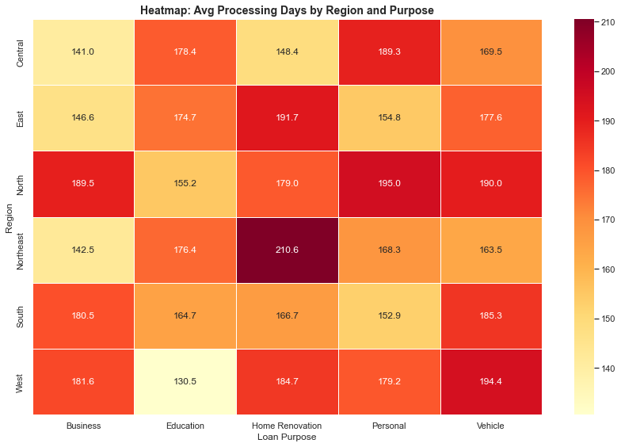
🐢 Slowest Bottleneck: Northeast Region for Home Renovation Loans
⚡ Fastest Process: West Region for Education Loans

Task 12 - Profitability Analysis

Calculating the total interest income generated across all loans
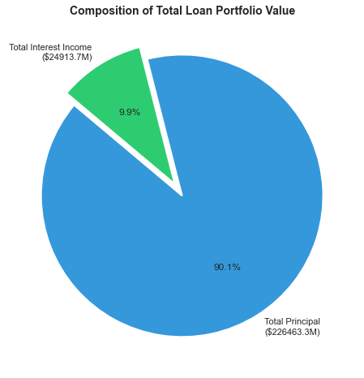
💰 FINANCIAL REVENUE SUMMARY 💰
---------------------------------------------
Total Principal Disbursed: $226,463,279,663.00
Total Projected Interest: $24,913,672,008.74
Average Interest Rate: 11.01%
---------------------------------------------
Total Expected Revenue: $251,376,951,671.74

Identifing the most profitable loan purposes based on interest earnings
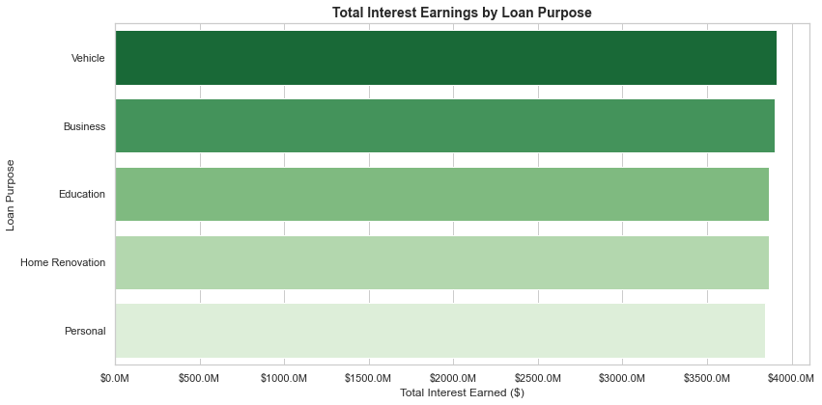
💎 Profitability Rankings by Loan Purpose:
---------------------------------------------
Vehicle: $3,910,158,757.13
Business: $3,897,289,983.39
Education: $3,867,958,675.34
Home Renovation: $3,867,923,730.91
Personal: $3,841,359,713.71

Comparing profitability metrics for branches across regions
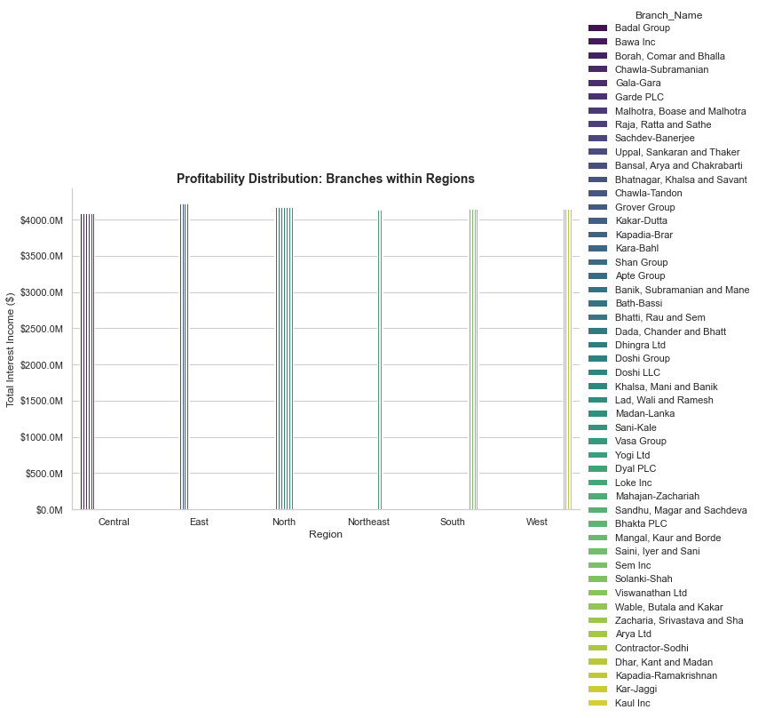
🌍 Regional Profitability Leaderboard:
---------------------------------------------
North: $58,468,446,969.76
Central: $40,894,853,495.88
East: $33,778,190,137.92
South: $33,132,323,853.70
West: $24,879,029,116.02
Northeast: $16,550,199,667.32

Task 13 - Geospatial Analysis

Mapping the distribution of active loans across regions

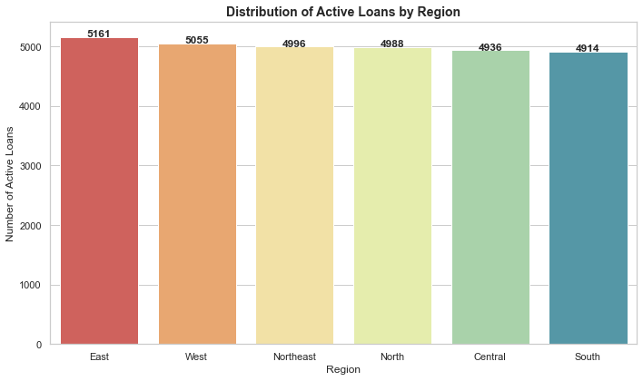
📍 Active Loan Density per Region:
-----------------------------------
Region Active_Loan_Count
East 5161
West 5055
Northeast 4996
North 4988
Central 4936
South 4914

Comparing default rates across different geographic regions

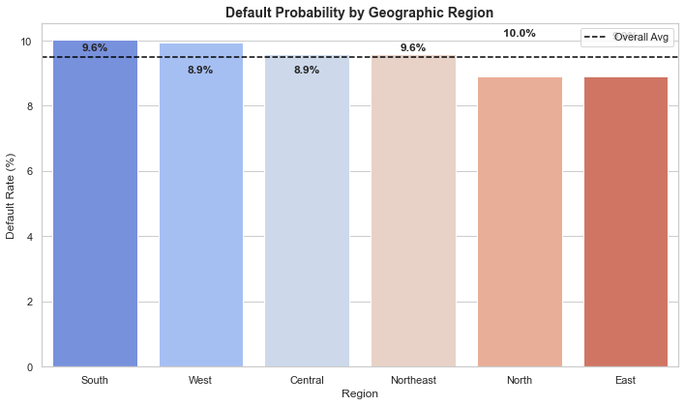
🚩 Regional Default Rankings:
-----------------------------------
Region Default_Rate_%
South 10.040805
West 9.932219
Central 9.583137
Northeast 9.582441
North 8.908982
East 8.899190

Visualizing the loan disbursement trends for rural vs. urban areas¶

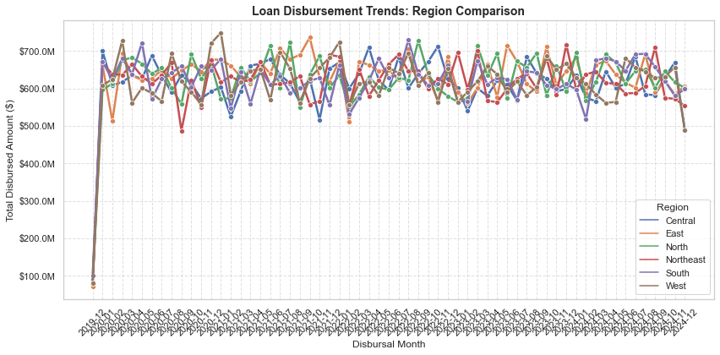
📊 Summary of Disbursement by Region:
---------------------------------------------
East: $38,437,798,746.00
North: $37,963,952,967.00
South: $37,740,573,537.00
West: $37,600,155,243.00
Northeast: $37,477,362,151.00
Central: $37,243,437,019.00

Task 14 - Default Trends

Analyzing the number of defaults over time to identify patterns

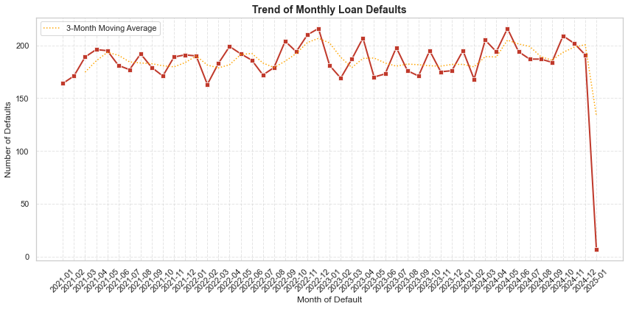
📉 Default Trend Insights:
---------------------------------------------
Average Defaults per Month: 183.7
Latest Month (2025-01): 7 defaults
✅ Defaults are currently below the historical average.

Calculating the average default amount for different loan purposes
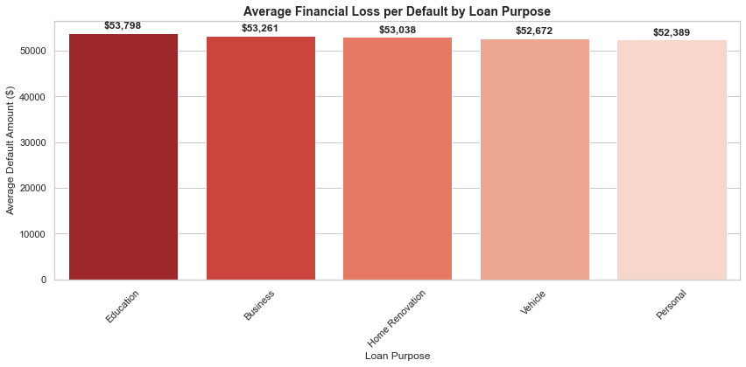
💸 Average Financial Impact of a Single Default:
---------------------------------------------
Education: $53,797.76
Business: $53,261.03
Home Renovation: $53,038.08
Vehicle: $52,671.60
Personal: $52,389.40

Comparing default rates across customer income categories

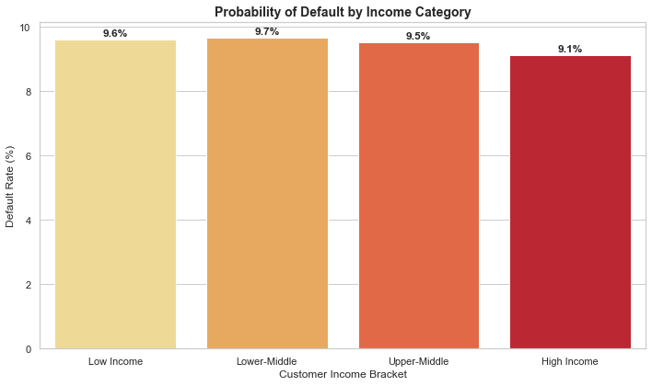
📊 Income-Based Risk Analysis:
---------------------------------------------
Low Income: 9.60% default probability
Lower-Middle: 9.68% default probability
Upper-Middle: 9.53% default probability
High Income: 9.14% default probability

Task 15 - Branch Eﬃciency

Calculating the average loan disbursement time for each branch¶

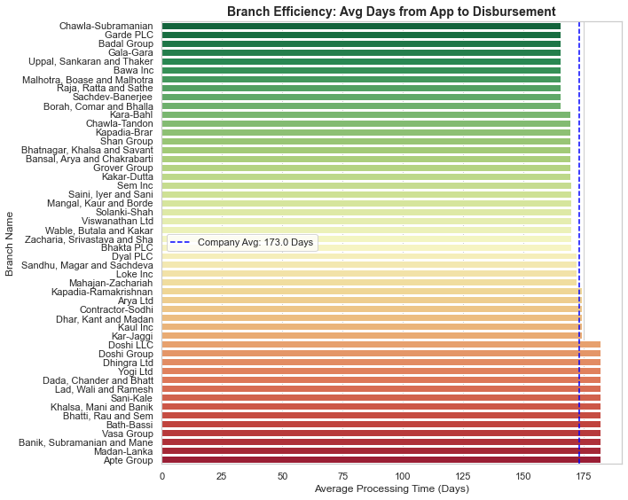
🚀 THE EFFICIENCY LEADERBOARD 🚀
---------------------------------------------
Most Efficient: Chawla-Subramanian (165.5 days)
Least Efficient: Apte Group (181.8 days)

Identifing branches with the highest number of rejected applications

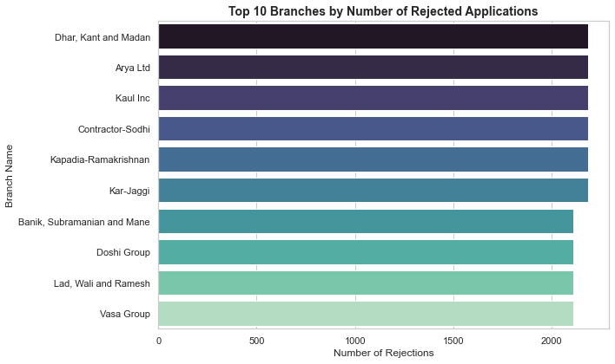
❌ REJECTION ANALYSIS ❌
---------------------------------------------
Branch with Most Rejections: Dhar, Kant and Madan
Total Rejections at this Branch: 2184

Compare branch eﬃciency based on customer satisfaction metrics (if available)
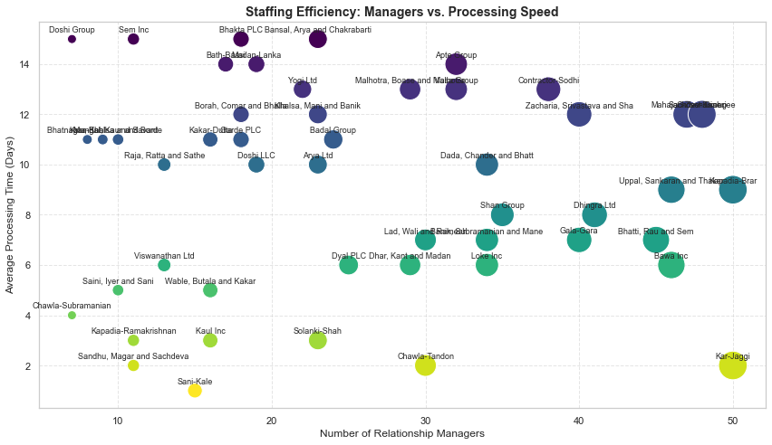
📊 Staffing Correlation: -0.00
---------------------------------------------
✅ Insight: More managers generally lead to SHORTER processing times. Staffing up works!

Task 16 - Time-Series Analysis

Analyzing monthly loan disbursement trends over the last 5 years¶
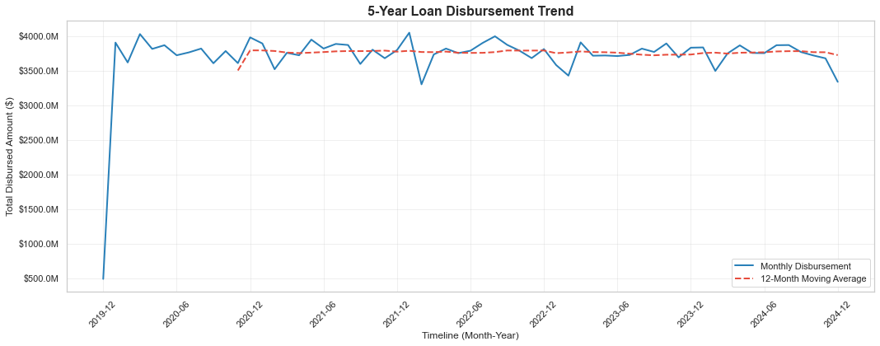
📈 5-Year Growth Analysis:
---------------------------------------------
Average Monthly Disbursement (Year 1): $3,505,085,450.08
Average Monthly Disbursement (Year 5): $3,727,572,286.17
Overall Portfolio Growth: 6.35%

Identifing seasonal patterns in loan applications and disbursements¶

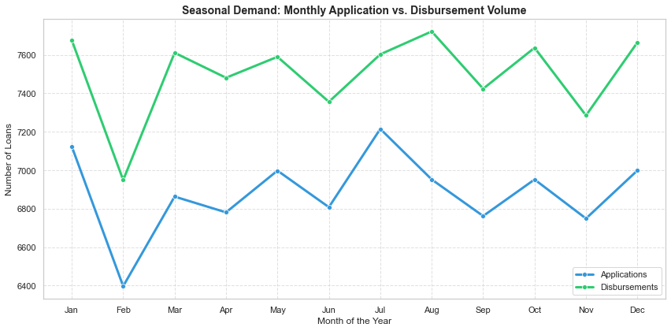
🗓️ SEASONAL INSIGHTS:
---------------------------------------------
Peak Application Month: Jul
Peak Disbursement Month: Aug

Comparing monthly default rates across regions
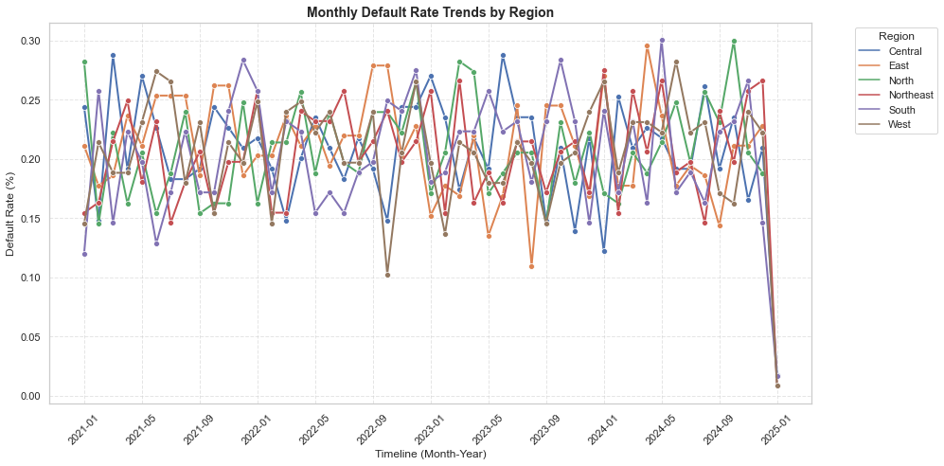

Task 17 - Customer Behavior Analysis

Categorizing customers based on their repayment behavior (e.g., always on time, occasional defaulters, frequent defaulters)
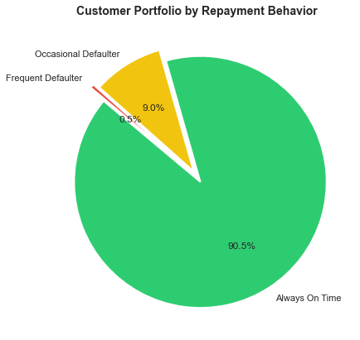
📊 Behavioral Segment Breakdown:
---------------------------------------------
Always On Time 63346
Occasional Defaulter 6310
Frequent Defaulter 344
Name: Repayment_Segment, dtype: int64

Analyzing patterns in loan approval and rejection reasons segmented by customer demographics
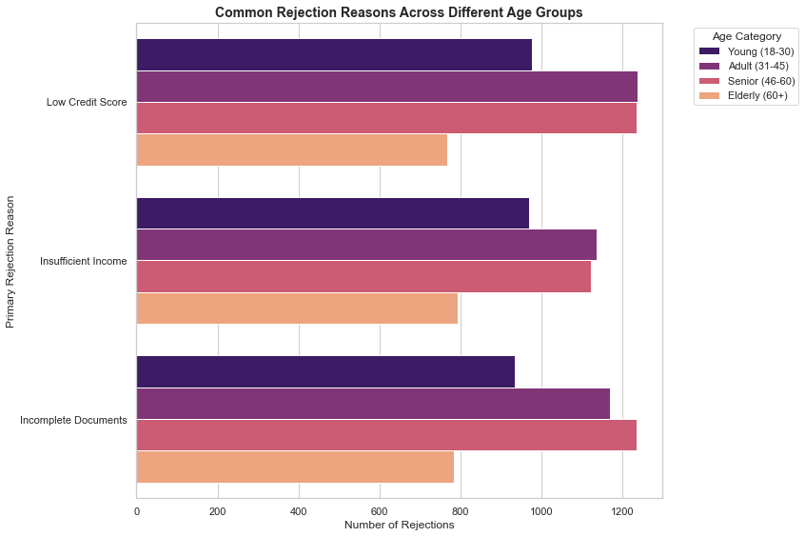
🧬 DEMOGRAPHIC INSIGHTS:
---------------------------------------------
Approval_Status Approved Rejected Approval_Rate_%
Gender
Female 23171 4180 84.717195
Male 23448 4201 84.805960
Other 23381 4219 84.713768

Identifying high-value customers with consistent repayment histories¶

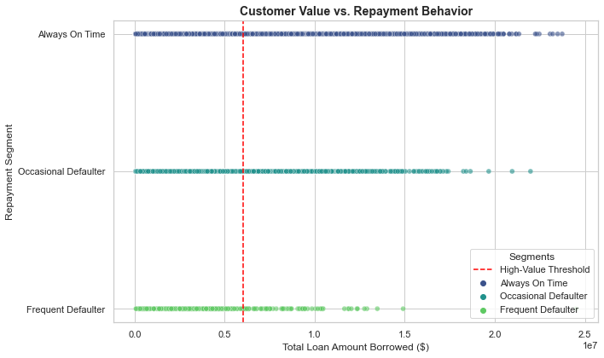
🌟 VIP CUSTOMER ANALYSIS 🌟
---------------------------------------------
Total Consistent Customers: 45858
Identified VIPs (Top 25%): 11465
Minimum VIP Loan Value: $6,015,161.25

Task 18 - Risk Assessment

Developing a risk matrix for loan products based on Default_Amount,Loan_Term, and Interest_Rate

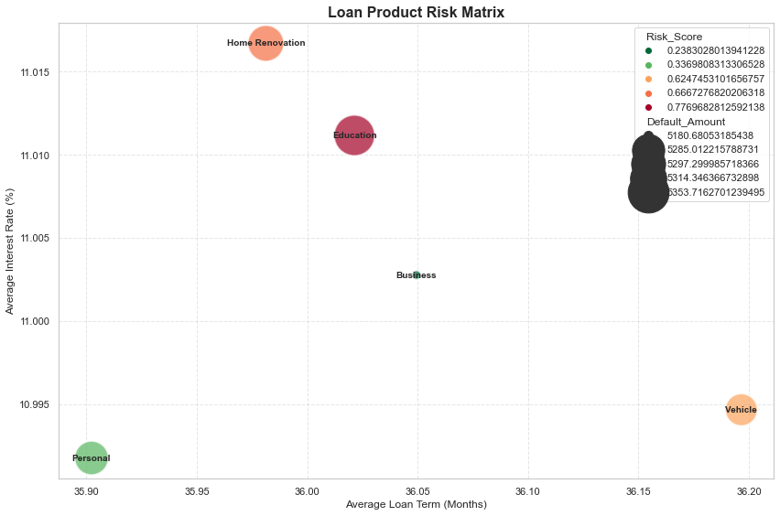
⚖️ PRODUCT RISK RANKINGS (High to Low):
---------------------------------------------
Loan_Purpose Risk_Score
Education 0.776968
Home Renovation 0.666728
Vehicle 0.624745
Personal 0.336981
Business 0.238303

Ranking loan types by risk level and suggest mitigation strategies
🏆 LOAN TYPE RISK RANKING & STRATEGY
--------------------------------------------------------------------------------
Loan_Purpose Risk_Score Risk_Tier Mitigation_Strategy
Education 0.776968 High Risk Require Collateral + Manual Underwriting
Home Renovation 0.666728 High Risk Require Collateral + Manual Underwriting
Vehicle 0.624745 Medium Risk Higher Interest Rate + Co-signer Required
Personal 0.336981 Medium Risk Higher Interest Rate + Co-signer Required
Business 0.238303 Low Risk Automated Approval + No Prepayment Penalty

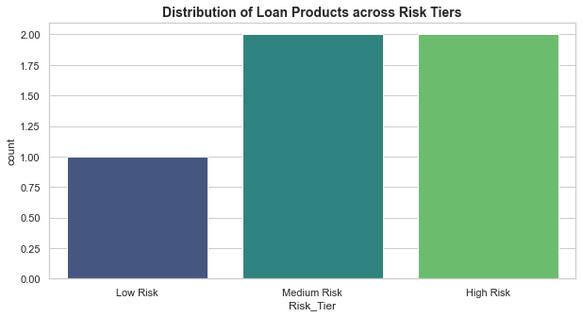

Analyzing high-risk customer segments by credit score and income¶

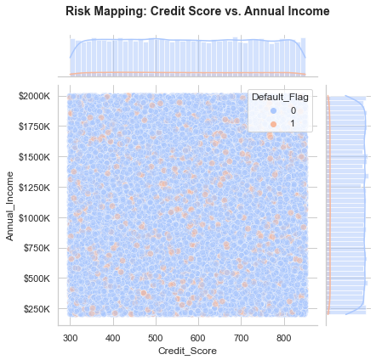
📊 Correlation Insights:
---------------------------------------------
Credit Score vs Default: -0.00
Income vs Default: -0.01

Task 19 - Time to Default Analysis

Calculating the average time from loan disbursement to default for overdue loans
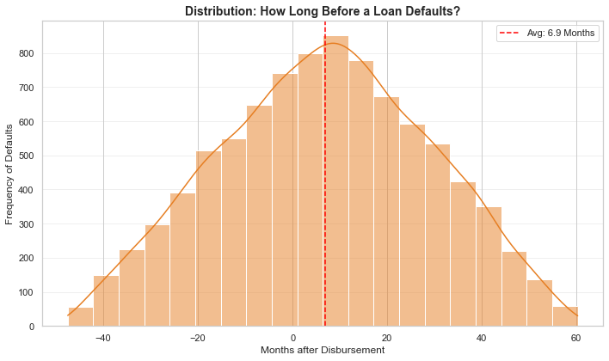
⏱️ TIME TO DEFAULT INSIGHTS
---------------------------------------------
Average Survival Time: 6.9 Months
ℹ️ MODERATE: Most defaults are happening mid-term. This is common in personal lending.

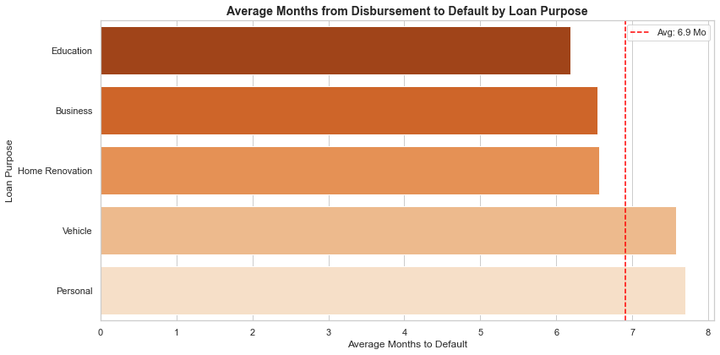
🚨 EARLY FAILURE ANALYSIS 🚨
---------------------------------------------
Product with FASTEST Default: Education
Average Time to Fail: 6.2 Months

Comparing the time to default across customer demographics
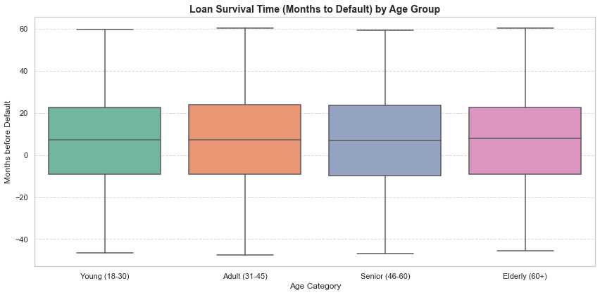
Average Months to Default by Gender:
---------------------------------------------
Gender Months_to_Default
0 Female 6.505947
1 Male 6.582380
2 Other 7.570451

20. Transaction Pattern Analysis

Identifying customers with irregular repayment patterns

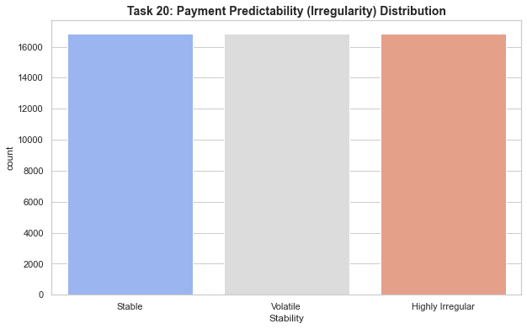
🚩 Most Irregular Customers (High Risk of Future Default):
Customer_ID Irregularity_Score Stability
46453 C064322 1178.039897 Highly Irregular
31672 C043921 1163.897762 Highly Irregular
31958 C044315 1136.320597 Highly Irregular
1753 C002415 1135.613491 Highly Irregular
25409 C035324 1120.764248 Highly Irregular

Analyzing penalty payments as a proportion of total transactions
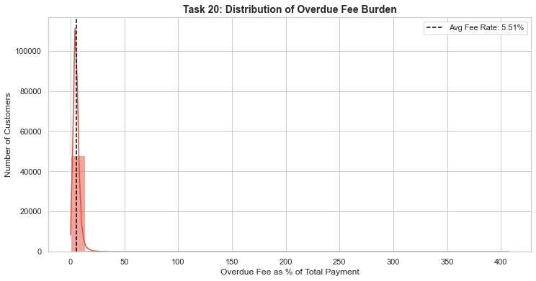
💰 PORTFOLIO REVENUE HEALTH
---------------------------------------------
Total Amount Collected: $12,620,730,053.00
Total Overdue Fees: $630,299,779.00
Revenue Quality Ratio: 95.01% (Principal/Interest)
Fee Dependency Ratio: 4.99% (Penalties)

Comparing transaction amounts for overdue vs. non-overdue loans
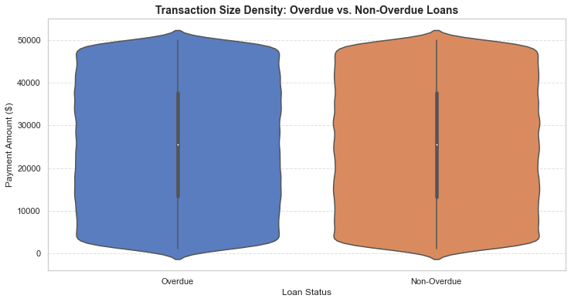
📈 Transaction Amount Comparison:
------------------------------------------------------------
Loan_Overdue_Status mean median std count
Non-Overdue 25462.476459 25455.0 14156.105728 247912
Overdue 25530.485451 25528.0 14131.846521 247088

💡 Insight: Overdue loans have an average payment that is -0.27% smaller than healthy loans.
\

